THE EAR

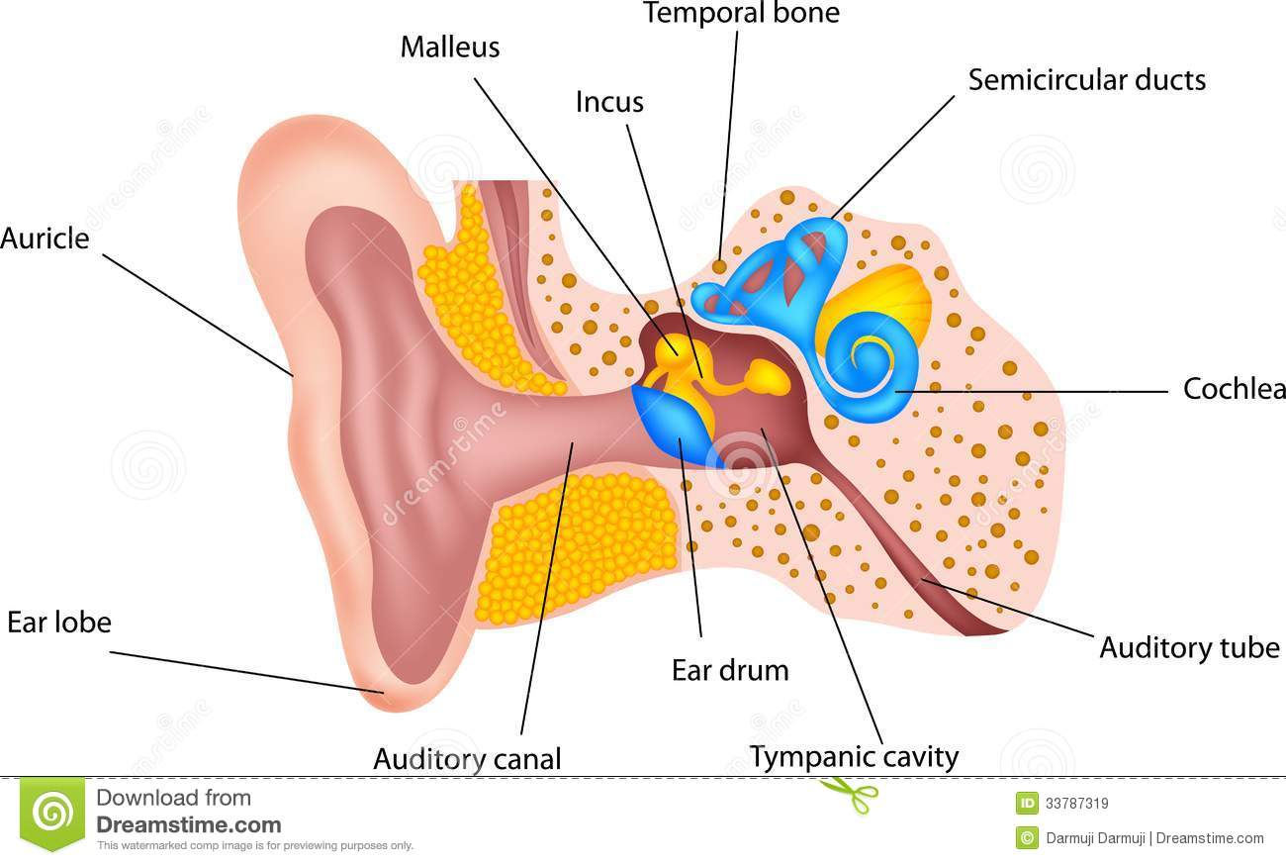

Find the above terminology in your target language and label the picture.

ENGLISH | SPANISH
Ear lobe
Auricle
Malleus
Incus
Temporal bone
Semicircular ducts
Cochlea
Auditory tube
Tympanic cavity
Ear drum
Auditory canal

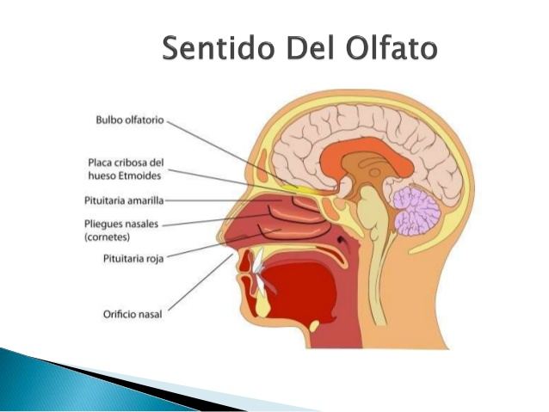

Find the above terminology in English and label the picture.

SPANISH | ENGLISH
Bulbo olfatorio
Placa cribosa del hueso etmoides
Pituitaria amarilla
Pliegues nasales
Pituitaria roja
Orificia nasal

MATCHING NEUROLOGY

COLUMN 1 COLUMN 2
___Lumbar puncture 1. Paralysis of all four limbs
___Electroencephalogram 2. Responsible for hearing and smell
___Seizures 3.Dilatation of a cerebral artery
___Quadriplegia 4. Physician who specializes/nerve diseases
___Temporal lobe 5. Irregular electrical activity in the body
___Neurosurgeon 6. Laboratory test of CSF
___Neurologist 7. Measure of electrical brain activity
___Cerebral aneurysm 8. Surgeon who specializes in neurosurgery

WORD FIND NEUROLOGY

Anticonvulsant
Audiometer
Cat scan
Cerumen
Cleft lip
Dementia
Meninges
Migraines
Neuron
Reflex
Sedative
Sinusitis
Stroke
Vagus nerve
WORD SCRAMBLE NEUROLOGY

1. V R E E N
2. E U N N O R
3. S S S E E N
4. E N I L Y M
5. N L I P S A
6. R D O C
7. H A S H T E

MULTIPLE CHOICE NEUROLOGY

1. Select the term that describes weakness or paralysis of the muscles of one side of the face
a. Cerebrovascular accident
b. Bell’s palsy
c. Cerebral palsy
d. Multiple sclerosis

2. Which test or procedure is used to assess cerebral function?
a. Electroencephalography
b. Evoked potential studies
c. Cerebral spinal fluid
d. Romberg test

3. Select the term that means the process of recording the electrical activity of the brain
a. Electroencephalography
b. Electroencephalogram
c. Evoked potential studies
d. Echoencephalography

4. Which part of the brain is responsible for maintaining muscle tone, movement, and balance?
a. Cerebrum
b. Midbrain
c. Cerebellum
d. Medulla oblongata

5. Which term best describes the swelling or bleed between the cranium and the Dura matter?
a. Epidural hematoma
b. Subdural hematoma
c. Subarachnoid hematoma
d. Concussion

VOCABULARY NEUROLOGY/EENT
TERM | IS THIS TERM A HIGH OR LOW REGISTER TERM? | WHAT IS THE TERM IN THE ALTERNATIVE REGISTER? | TRANSLATE TO TARGET LANGUAGE LOW | TRANSLATE INTO TARGET LANGUAGE HIGH
Pterygium
Removing tonsils
Meningitis
Blood clot in the brain
Stroke
Eardrum
Cochlear implant
Ear wax
Neuron
Sinus infection
Spinal cord
Reflex
EEG
Throat doctor

CASE STUDY NEUROLOGY

Read the following discharge summary. Answer the questions below. Be prepared to sight interpret the document.
DISCHARGE SUMMARY
PATIENT: D.W
DATE OF ADMISSION: DATE OF DISCHARGE:
DISCHARGE DIAGNOSES:
1. CVA
4. Diabetes Mellitus
5. Hypertension
6. Hyperlipidemia
7. Slight dementia

HISTORY: This is an 80-year-old male who was brought into the hospital after complaining of sudden weakness in his left side and face, drooping left side of mouth which lasted several minutes and did not resolve completely before his wife called the ambulance. The patient’s history includes: high blood pressure, hypercholesterolemia, diabetes Mellitus, slight dementia, and a recent CVA.
PHYSICAL EXAMINATION: physical examination revealed a healthy appearing man with some left facial drooping and left sided weakness. Vital signs were: blood pressure of 190/110, respirations 20, pulse 110. Patient was admitted to the ICU for possible stroke. Stroke protocols were instituted as soon as the patient arrived in the emergency room. The patient responded well to treatment and was discharged a week later in stable condition and placed on Coumadin and Lovenox. The patient will follow up with the neurologist in one week.
Case study questions:
- What is a CVA?

2. What side of the brain was affected in the stroke?
3. Do you think his other problems such as heart disease and diabetes contributed to his stroke? If so, why?

CONTINUOUS REFLECTIONS OF THE STUDENT

Think about making an ongoing commitment to professional health care interpreting. Based on the training so far, write down what you will start doing, stop doing, and continue doing.

I will start:

I will stop:

CONTINUOUS REFLECTIONS OF THE STUDENT

I will continue:

