THE BREAST
Find the terminology in your target language and label the picture.

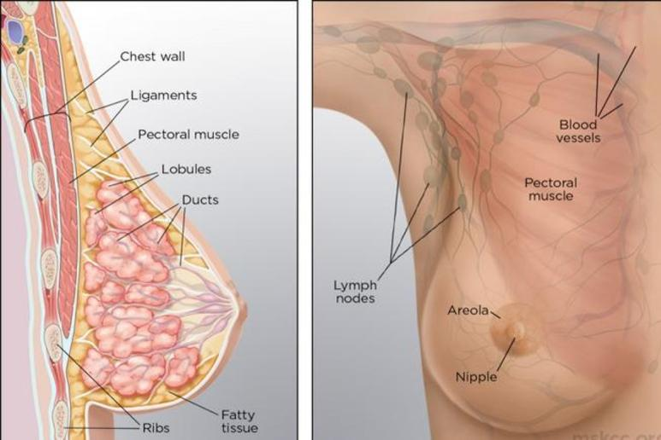

ENGLISH | SPANISH
Ligaments
Pectoral muscle
Lobules
Ducts
Aerola
Nipple

MATCHING GYNECOLOGY/REPRODUCTION

COLUMN 1 COLUMN 2
___Ovaries 1. Excessive menstrual bleeding
___Fallopian tubes 2. Removal of uterus
___ Hypermenorrhea 3. Tubal pregnancy
___IUD 4. Produce eggs or ova
___Hysterectomy 5. Contraceptive device
___Ectopic pregnancy 6. Carry mature ova to the uterus

WORD SCRAMBLE GYNECOLOGY/REPRODUCTION

1. S U T E F
2. E E R C B H
3. O R A B L
4. S A G O N D
5. M O H N E O R S
6. C M U C I N S R O I C I
7. T O N I C M A I D L I F U
8. T R I H B N L A C A

MULTIPLE CHOICE GYNECOLOGY/REPRODUCTION

1. Menarche is another word for:
a. Menopause
b. Menstruation
c. Myometrium
d. Perimenopause

2. A gynecologist is a doctor who specializes in:
a. Treatments of diseases of the female reproductive organs
b. Treatments of disorders of the female reproductive organs
c. Medical care during pregnancy and childbirth
d. Both A&B

3. Contraception includes:
a. Intrauterine device
b. Birth control pills
c. Tubal ligation
d. All of the above

4. Release of a mature egg is known as:
a. Conception
b. Fertilization
c. Ovulation
d. Coitus

5. The temporary organ that is formed in the uterus during pregnancy to deliver nutrients to the fetus is called:
a. Chorion
b. Amniotic sac
c. Umbilical cord
d. Placenta

VOCABULARY GYNECOLOGY/REPREODUCTION

TERM | TARGET LANGUAGE
Gravida
Amniotic fluid
Follicle
Testes
Prostate gland
Placenta
Sperm
Cesarean section
Impotence
Ovaries
Prima-gravida
Cervix
Salpingogram
STD (sexually transmitted disease)
Breach
Umbilical cord
Epidural
Amniotic fluid and sac

CASE STUDY GYNECOLOGY/REPRODUCTION

The interpreter is with a Spanish speaking patient who is getting ready to deliver vaginally. However, the labor has gone past 24 hours and the patient is not completely dilated. The patient is on a fetal monitor and an epidural anesthesia was put in place in the lumbar spine. It was decided that there was fetal distress and the mother was moved to the operating room for a Cesarean birth. The interpreter accompanied the woman into the operating room and stayed with her the whole time. The baby was born normal without further event.
1. What is a Cesarean birth?

2. What is an epidural?

3. Why did the interpreter need to accompany the mother into the operating room?

