MATCHING ENDOCRINOLOGY

COLUMN 1 COLUMN 2
___Diabetes type II 1. Control electrolyte levels
___Insulin 2. Endocrine gland secretions
___ Hormones 3. Insulin resistance disorder
___Thyroid gland 4. Pancreatic hormone secretion
___Adrenal glands 5. A test of blood sugar levels
___Fasting blood sugar 6. Regulate body metabolism

MULTIPLE CHOICE ENDOCRINOLOGY

1. The inability of the pancreas to produce insulin is called:
a. Diabetes type II
b. Gestational diabetes
c. Diabetes type I
d. Polydipsia

2. Insulin resistance is also known as:
a. Diabetes type II
b. Gestational diabetes
c. Diabetes type I
d. Pancreatitis

3. Diabetes due to pregnancy is also known as:
a. Diabetes type II
b. Diabetes type I
c. Gestational diabetes
d. Hypoglycemia

4. The primary function of the adrenal gland is:
a. Development of the sex characteristics
b. To control electrolytes in the body
c. Regulate metabolism
d. Both B &C

5. Insulin shock is a diabetic emergency due to:
a. Very low blood sugar
b. Diabetic coma
c. Very high blood sugar
d. Diabetic ketoacidosis

WORD FIND ENDOCRINOLOGY

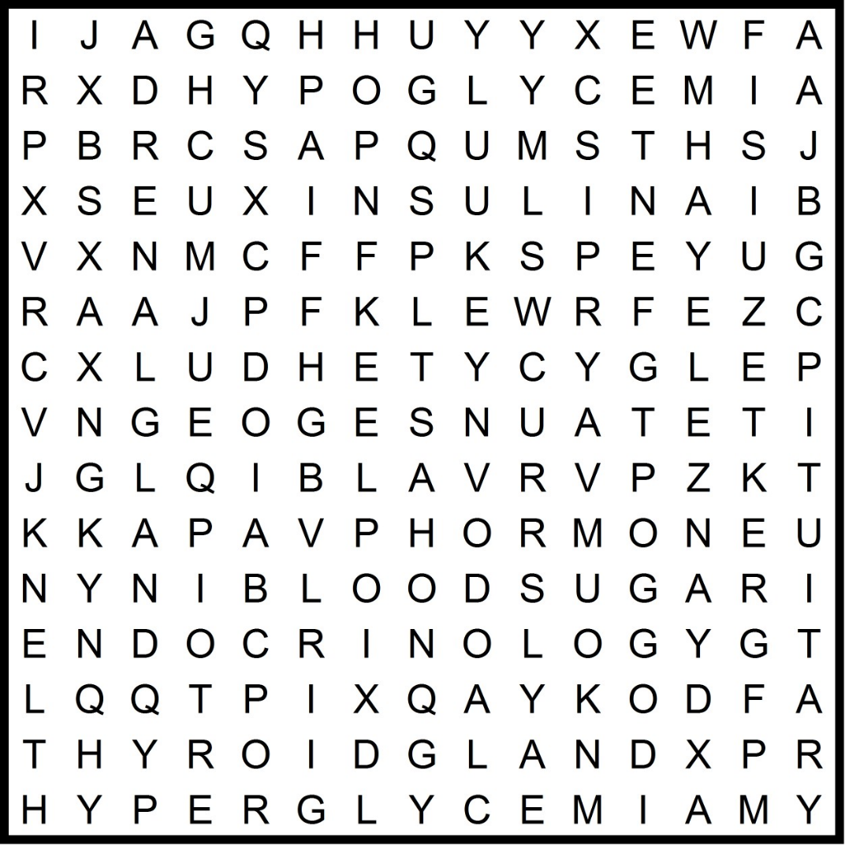

Adrenal gland, hyperglycemia, thyroid gland, hypoglycemia, insulin, diabetes, pancreas, hormone, pituitary, blood sugar, endocrinology

ENDOCRINOLOGY CROSSWORD
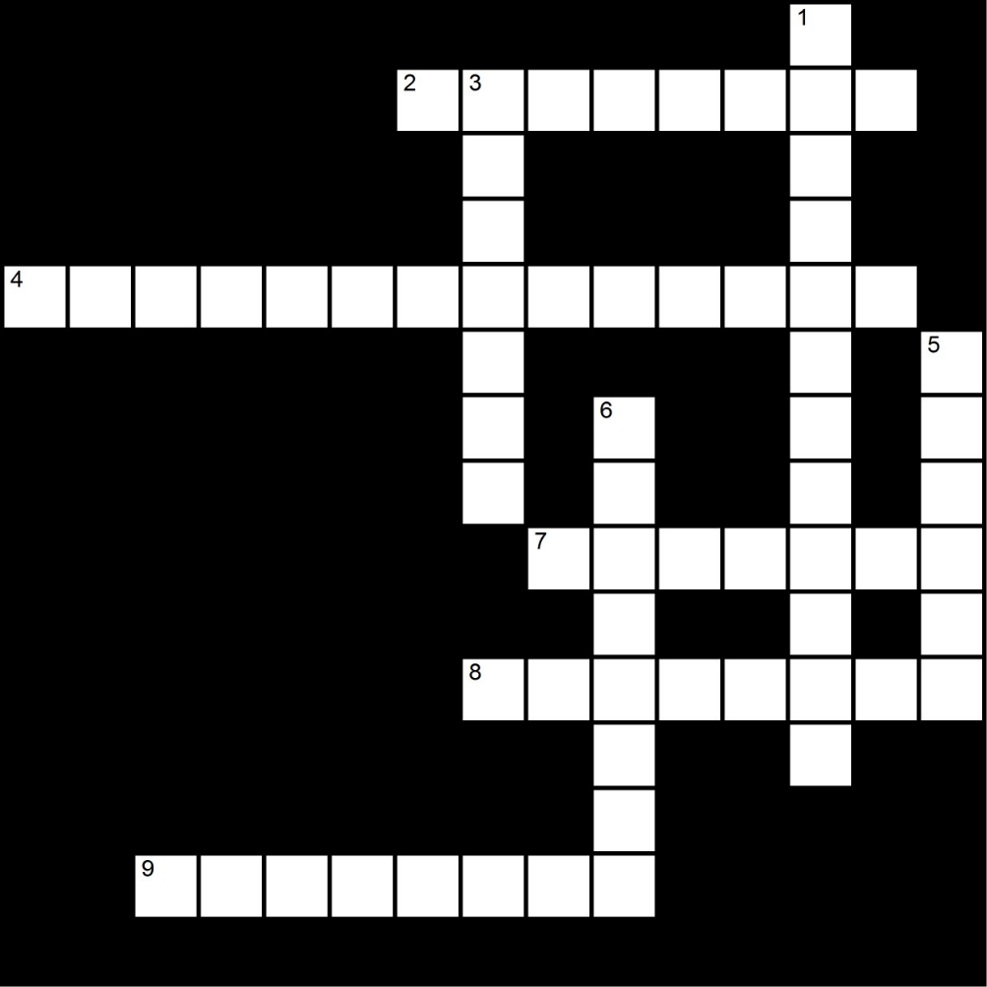
Across Down

2. hormone like substances 1. Glands that control electrolyte
Secreted by endocrine glands levels in the body

4. secretes hormones that control 3. Gland that regulates the body’s
The activity of other hormones metabolism

7. hormone secreted by the pancreas 5. Specialized cells capable of
Producing secretions
8. chemical messengers that are
Secreted by endocrine glands 6. Organ that produces insulin

9. condition where the pancreas
No longer produce insulin or
The body is insulin resistant
VOCABULARY ENDOCRINOLOGY

TERM | DEFINITION | TARGET LANGUAGE
Ketoacidosis
Diabetes
Adrenal gland
Gonad
Hypoglycemia
Hyperglycemia
Thyroid
Hemoglobin A1c test
Hormones
Pituitary
Glands
Hyperthyroidism
Pancreas
Metabolism
Gestational diabetes

CASE STUDY ENDOCRINOLOGY

A diabetic nutrition counselor is working with a type II diabetic woman who has recently arrived from Mexico. The nutritionist asks the woman about her diet and gives her a list of foods that she can choose from. The list is designed for the American palate. Foods such as Graham Crackers, English muffins, waffles are on the list. The patient seems confused and does not recognize some of the foods on the list. When asked what time she eats breakfast, the patient responds “around 11:00 am.” The nutritionist then states. “no, no, I mean breakfast.” The patient looks confused.
1. What are the cultural dynamics in this situation?

2. Should the interpreter intervene? If so, how and why?

3. Are the foods that are popular in America popular as well in other countries? What can the interpreter do to help the nutritionist in her work?

